YUVAA INTERN • WEEK 3

STATISTICAL ANALYSIS
& HYPOTHESIS TESTING IN PYTHON
Professional Internship Deliverable

DETAIL | INFORMATION
Student | Pushpak Koppada
Program | B.Tech CSE (AI & ML)
Institution | Lovely Professional University
Internship Task | Week 3 — Statistical Analysis and Hypothesis Testing in Python
Dataset | 300 observations • 4 analytical variables
Technology Stack | Python • Pandas • NumPy • SciPy • Statsmodels • Matplotlib
Statistical Methods | Welch’s t-test • One-way ANOVA • Chi-square • 95% CI
Prepared for academic and internship evaluation

Report Overview
This single-file submission contains the complete analytical workflow, including the dataset profile, methodology, statistical outputs, visual evidence, interpretation, Python implementation, limitations, and final conclusion.
- Executive Summary
- Objectives and Problem Statement
- Hypotheses
- Dataset and Data Preparation
- Exploratory Data Analysis
- Statistical Methodology
- Results and Interpretation
- Visual Analysis
- Assumptions and Validity
- Limitations and Future Work
- Reproducibility / Python Code
- Conclusion
- Internship Submission Checklist
- References

1. Executive Summary
This project applies an end-to-end statistical analysis workflow in Python to determine whether observed differences and relationships in a structured dataset are statistically meaningful. The analysis uses 300 observations and combines descriptive statistics, inferential hypothesis testing, confidence intervals, effect-size interpretation, and visualization. The objective is not merely to calculate p-values, but to demonstrate a professional process for translating an analytical question into testable hypotheses, selecting appropriate statistical procedures, interpreting uncertainty, and communicating conclusions.
Three primary tests were performed. Welch’s independent-samples t-test compared the mean metric of two independent groups; one-way ANOVA compared the metric across three segments; and a chi-square test of independence examined the association between group membership and a categorical outcome. All three tests returned p-values below the 0.05 significance threshold. Welch’s t-test: p = 5.106e-21; ANOVA: p = 1.651e-02; chi-square: p = 3.388e-13. The corresponding null hypotheses are therefore rejected at the 5% significance level.

2. Objectives
- Define clear, measurable and testable hypotheses.
- Prepare and inspect a structured dataset for statistical analysis.
- Select statistical tests appropriate to the research questions and variable types.
- Calculate and interpret test statistics, p-values, confidence intervals and effect size.
- Use visualizations to communicate patterns and support statistical findings.
- Produce a reproducible, professional internship deliverable using Python.

3. Problem Statement
A difference observed in sample data does not automatically imply that a genuine difference exists in the wider population. The analytical problem is therefore to determine whether differences between the two primary groups, differences among three segments, and the relationship between group and outcome are statistically significant rather than plausibly attributable to random variation.

4. Hypotheses
TEST | NULL HYPOTHESIS (H₀) | ALTERNATIVE HYPOTHESIS (H₁)
Welch’s t-test | The two group means are equal. | The two group means are different.
One-way ANOVA | All three segment means are equal. | At least one segment mean is different.
Chi-square | Group and outcome are independent. | Group and outcome are associated.

5. Dataset and Data Preparation
The analytical dataset contains 300 observations and four variables. The numerical Metric is the primary response variable. Group contains two independent comparison groups; Segment contains three categorical levels; and Outcome is a binary categorical variable used for the chi-square analysis.
VARIABLE | TYPE | ROLE IN ANALYSIS
Group | Categorical | Two-group comparison
Metric | Continuous | Primary numerical outcome
Segment | Categorical | Three-group comparison
Outcome | Categorical | Categorical association analysis
The workflow includes loading the CSV data, reviewing structure and descriptive statistics, separating numerical groups for the t-test, constructing segment-wise samples for ANOVA, and generating a contingency table for the chi-square test. The source code is embedded later in this same document so the report remains self-contained.

6. Exploratory Data Analysis
GROUP | N | MEAN | STD. DEV. | MEDIAN
Control | 150 | 71.34 | 7.54 | 71.56
Treatment | 150 | 80.57 | 8.17 | 81.14
The Control group has a mean Metric of 71.34, while the Treatment group has a mean of 80.57. The observed difference is 9.23 units. Descriptive statistics establish the pattern, while inferential tests determine whether the evidence is statistically strong enough to reject the relevant null hypothesis.
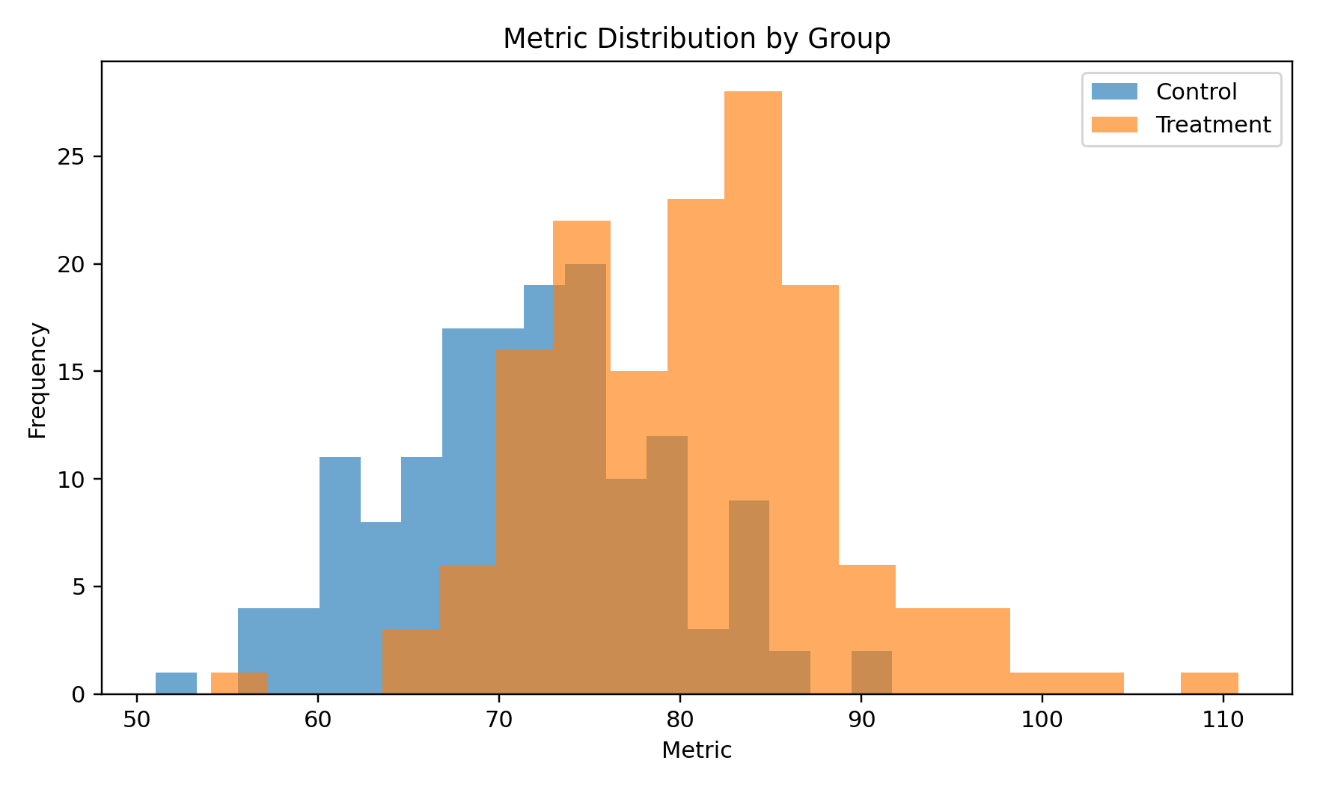
Figure 1 — Distribution of Metric by Group.
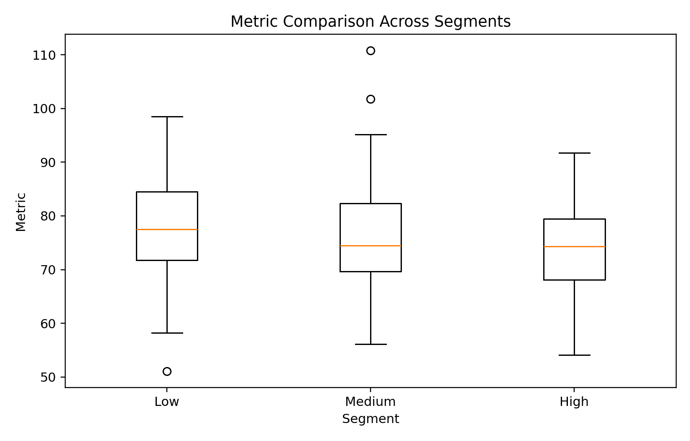
Figure 2 — Metric comparison across Low, Medium and High segments.

7. Statistical Methodology

7.1 Welch’s Independent-Samples t-Test
Welch’s t-test compares the means of two independent groups without requiring equal population variances. It is appropriate when the response variable is continuous and the observations are independent. The decision rule is based on the p-value relative to α = 0.05.

7.2 One-Way ANOVA
One-way ANOVA tests whether the means of three or more independent groups are all equal. A significant F-statistic indicates that at least one group mean differs. If the result is significant, post-hoc pairwise testing is normally recommended to identify the specific differences.

7.3 Chi-Square Test of Independence
The chi-square test compares observed and expected frequencies in a contingency table. It evaluates whether two categorical variables are statistically independent. Here it tests whether Group and Outcome are associated.

7.4 Confidence Interval and Effect Size
A 95% confidence interval was calculated for the Treatment-minus-Control mean difference: [7.44, 11.02]. The standardized mean difference (Cohen’s d) is approximately 1.17, providing additional context about the magnitude of the group difference.

8. Statistical Results
ANALYSIS | STATISTIC | P-VALUE | ALPHA | DECISION
Welch’s t-test | -10.165 | 5.106e-21 | 0.05 | Reject H₀
One-way ANOVA | 4.161 | 1.651e-02 | 0.05 | Reject H₀
Chi-square | 52.970 | 3.388e-13 | 0.05 | Reject H₀

8.1 Welch’s t-Test Interpretation
The Welch’s t-test returned t = -10.165 and p = 5.106e-21. Because p < 0.05, the null hypothesis of equal group means is rejected. The 95% confidence interval for the mean difference is [7.44, 11.02], indicating a statistically supported difference between the two groups.

8.2 ANOVA Interpretation
The ANOVA produced F = 4.161 and p = 1.651e-02. The p-value is below 0.05, so the hypothesis that all three segment means are identical is rejected. The result establishes that at least one segment differs; it does not, by itself, identify the exact pairwise differences.

8.3 Chi-Square Interpretation
The chi-square test produced χ² = 52.970, degrees of freedom = 1, and p = 3.388e-13. Since p < 0.05, the null hypothesis of independence is rejected. The sample therefore provides statistical evidence of an association between Group and Outcome.
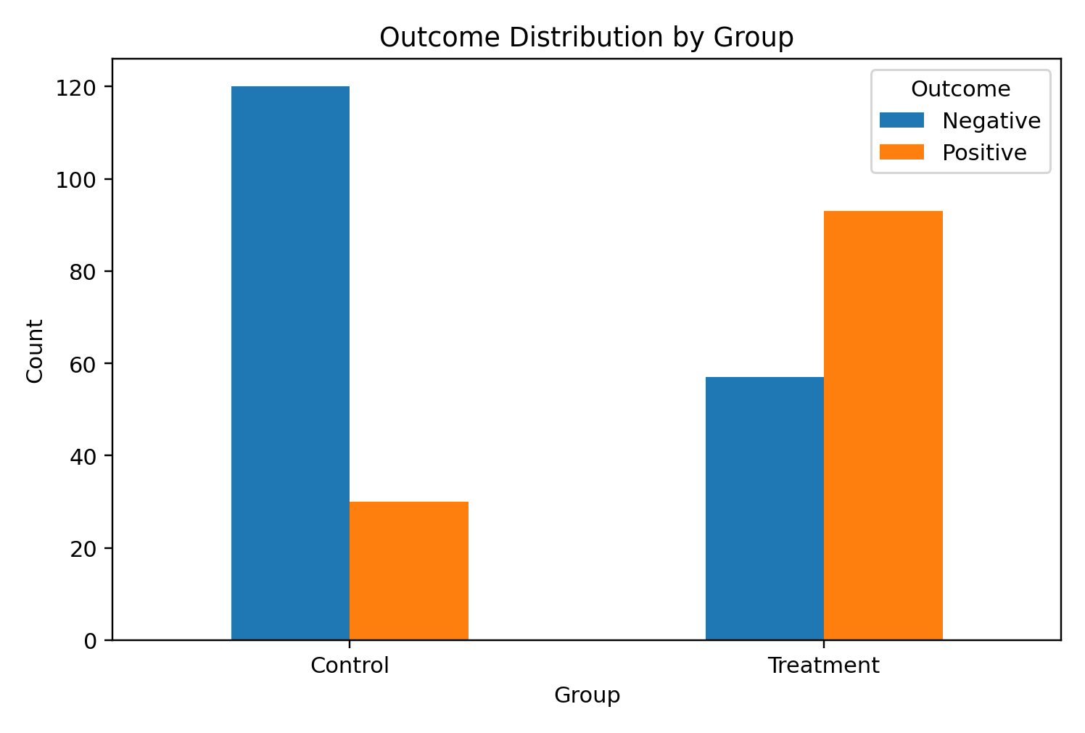
Figure 3 — Observed Outcome counts by Group.

9. Assumptions and Statistical Validity
- Independence: observations should be independently collected within the study design.
- Welch’s t-test: continuous response, independent observations, and reasonable distributional behavior within groups; it is robust to unequal variances.
- ANOVA: independent observations, approximately normal residuals within groups, and reasonably homogeneous variances.
- Chi-square: expected frequencies should be sufficiently large for the chi-square approximation to be reliable.
- Significance threshold: α = 0.05. A small p-value is evidence against H₀; it is not the probability that H₀ is true.

10. Integrated Findings
The three analyses provide complementary evidence. The t-test indicates a significant difference between the two primary groups. The ANOVA indicates that the numerical metric is not identical across all three segments. The chi-square test indicates an association between group membership and the categorical outcome. Together, these results show that the dataset contains statistically detectable structure across both numerical and categorical dimensions.
The results should nevertheless be interpreted within the scope of the dataset and study design. Statistical significance indicates that the observed pattern is unlikely under the corresponding null model; it does not establish causality, guarantee practical importance, or justify generalization to an unrelated population.

11. Limitations and Future Improvements
- The dataset is suitable for demonstrating statistical methodology, but external generalization requires representative real-world sampling.
- The current analysis does not establish causal relationships.
- ANOVA can be extended with Tukey HSD or another post-hoc procedure to identify which segment pairs differ.
- Additional diagnostics such as residual plots, variance checks, and bootstrap confidence intervals could strengthen robustness.
- Future versions could incorporate larger samples, real operational data, predictive modelling, and sensitivity analysis.

12. Reproducibility — Python Implementation
The following implementation is included directly in the report so the document remains self-contained. It demonstrates the core data-loading, statistical-testing, and result-generation workflow.
import pandas as pd
from scipy import stats
# Load dataset
df = pd.read_csv("week3_statistical_analysis_dataset.csv")
# Descriptive statistics
print(df.groupby("Group")["Metric"].describe())
# Welch's independent-samples t-test
control = df.loc[df["Group"] == "Control", "Metric"]
treatment = df.loc[df["Group"] == "Treatment", "Metric"]
t_stat, t_p = stats.ttest_ind(control, treatment, equal_var=False)
# One-way ANOVA
groups = [
df.loc[df["Segment"] == s, "Metric"]
for s in ["Low", "Medium", "High"]
]
f_stat, anova_p = stats.f_oneway(*groups)
# Chi-square test of independence
contingency = pd.crosstab(df["Group"], df["Outcome"])
chi2, chi_p, dof, expected = stats.chi2_contingency(contingency)
print("Welch t-test:", t_stat, t_p)
print("ANOVA:", f_stat, anova_p)
print("Chi-square:", chi2, chi_p)

13. Conclusion
This Week 3 project demonstrates a complete statistical hypothesis-testing workflow using Python. The process began with a clearly defined analytical problem and hypotheses, followed by dataset preparation, exploratory analysis, selection of appropriate statistical methods, inferential testing, visualization, and professional interpretation.
At the 5% significance level, the Welch’s t-test (p = 5.106e-21), one-way ANOVA (p = 1.651e-02), and chi-square test (p = 3.388e-13) all produced statistically significant results. The corresponding null hypotheses are therefore rejected. The confidence interval and effect-size estimate provide additional context beyond the p-values.
The project demonstrates practical skills in Python programming, data manipulation, statistical reasoning, visualization, and technical communication. The findings are reported with appropriate caution: they support statistically significant differences and associations in the analyzed dataset, but they should not be interpreted as causal proof without a stronger experimental or observational design.

14. Internship Submission Checklist
☑ Professional report completed.
☑ Hypotheses clearly stated.
☑ Dataset and variable definitions documented.
☑ Statistical methodology explained.
☑ Welch’s t-test, ANOVA and chi-square results included.
☑ p-values, confidence interval and effect size reported.
☑ Three supporting visualizations included.
☑ Interpretation, limitations and conclusion included.
☑ Python implementation embedded in this document.
☑ Single DOCX contains the complete submission material.

15. References
- Python Software Foundation. Python Documentation.
- Pandas Documentation. Data analysis and manipulation in Python.
- SciPy Documentation. Statistical functions and hypothesis testing.
- Statsmodels Documentation. Statistical modelling and inference in Python.
- Matplotlib Documentation. Visualization with Python.
END OF REPORT

